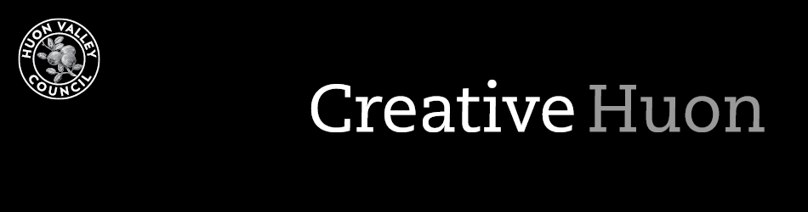

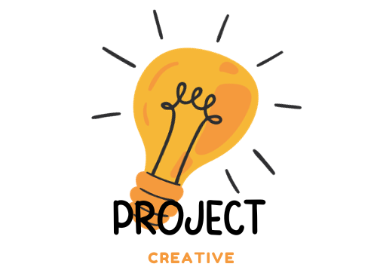

2023/2024
Creative Huon Grants – WINTER PROJECT
Guidelines and Application

Key dates

Monday 18 March 2024 | Applications open
Monday 15 April 2024 | Applications close
Monday 22 April 2024 | Successful applicant announced
Wednesday 24 April 2024 | Project start
Sunday 1 September 2024 | Project completion
Friday 4 October 2024 | Project acquittal

Creative Huon Grants
The Huon Valley Council offers a grant of $5,000 for an artist-led project for the community over the winter months. Please apply if you have a creative project in mind and are an artist, maker, creative community group, school, or organisation.

Funding
You can use a grant to fund:
- artist fees
- the purchase of project materials
- research
- travel
- marketing or promotional materials
- professional development opportunities.
All projects need to support and add to the creative spirit and expression in the community.
We cannot fund:
- ongoing administration or operational costs
- capital works
- competitions, awards, prizes, judging
- fundraising events
- projects that have already started
- late or incomplete applications.
You can only apply for one grant per year and must have acquitted any previous grants.

Who Can’t Apply?
- Australian or Local Government agencies or bodies
- Tasmanian Government agencies (except schools)
- Government Business Enterprises
- Applicants who have not fulfilled the conditions of a previous Council grant.

Budget requirements
You need to provide clear budget information which shows what costs you are asking to fund. Explain:
- how much money you need from the Grants Program and what you will spend it on.
- your budget breakdown (income, expenses, and in-kind support).
We can’t fund projects that make a big loss or profit.

assessment
We have a Creative Grants Panel which will assess your application. Your application must:
- align with at least one of the goals set out in the Arts and Culture Strategy.
- promote creative activities during winter in the Huon Valley.
- provide creative or cultural benefits to the community.
We will contact you if we need more information about your application.
The panel:
- prefers funding projects that think about how they can be sustained into the future.
- may recommend partial funding (cash or in-kind support) and will discuss this with you.
- makes recommendations and the decision is final.

Letter Of Offer
We will send successful applicants a formal Letter of Offer. This letter outlines the terms and conditions of the grant.
We will pay the grant after you provide:
- a signed Letter of Offer
- a tax invoice (inclusive of GST where applicable)
- your ABN.

Recognition of Council Assistance
If you are successful and have received a grant, you must acknowledge our support. You will receive a logo with the Letter of Offer. You must include the logo in all your media or publicity.
You must also include the following statement in all acknowledgements: “Proudly supported by Huon Valley Council Creative Grants Program”.

Acquittal
When you have finished your project, you must acquit your grant. Provide details of the project, including:
- expenses (including quotes)
- project outcomes
- media coverage (if applicable)
- high-resolution photos (if applicable)
- proof of community support and/or participation (if applicable)
- examples of how you acknowledged Council.
If you don’t acquit your grant to a reasonable standard, you may not be able to receive future funding. We may also ask you to return the funds allocated to your project.

UNSUCCESSFUL APPLICATIONS
We believe all ideas and projects are valuable and will give feedback if you are unsuccessful. If you have more specific questions, please reach out to us and we can talk them through with you.

how to apply
Please provide the following information:
Brief artist statement or organisation summary (150 words) | Your statement must demonstrate you are a professional or emerging artist. Write a summary if you are an organisation.
Impact statement (200 words) | Tell us about the benefits of the project to people in the community during winter.
Activity outline (350 words) | Tell us what you will do with the grant.
Budget | Provide a detailed budget breakdown of the grant funds. Include all income and in-kind support.
Supporting evidence | Provide any support letters that show the benefit of your project. You can also provide your CV, links to your work or other visual materials.

Contact Officer
Are you getting stuck? Talk to the Arts and Culture Officer who is happy to give you helpful tips for a successful application.
Arts and Culture Officer
Phone: (03) 6264 0300
Email: hvc@huonvalley.tas.gov.au

HUON VALLEY ARTS AND CULTURE GRANT PROGRAM – winter project - APPLICATION FORM

Applicant name
Contact name
Contact phone number
Contact email
Website
ABN
Do you or your organisation
live or work in the Huon Valley?
Artist/organisation statement/summary (150 words)
Write a short statement or summary on your art practice, your group, or your organisation.

Impact Statement (200 words)
Tell us how your project benefits the community.

Activity Outline (350 words)
Please tell us:
- the details of your project.
- your project timeline.
- how your project proposal is sustainable.

Grant Budget

INCOME

Item | Amount ($)
Total

EXPENSES
Item | Amount ($)
Total
IN-KIND SUPPORT
Item | Amount ($)
Total

supporting materials
You can include six to eight images, quotes, videos, website and social media links, or other documents related to your project.

Submission
Please email your application and support material to hvc@huonvalley.tas.gov.au.

We can’t accept late submissions.

