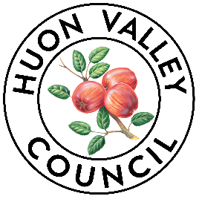

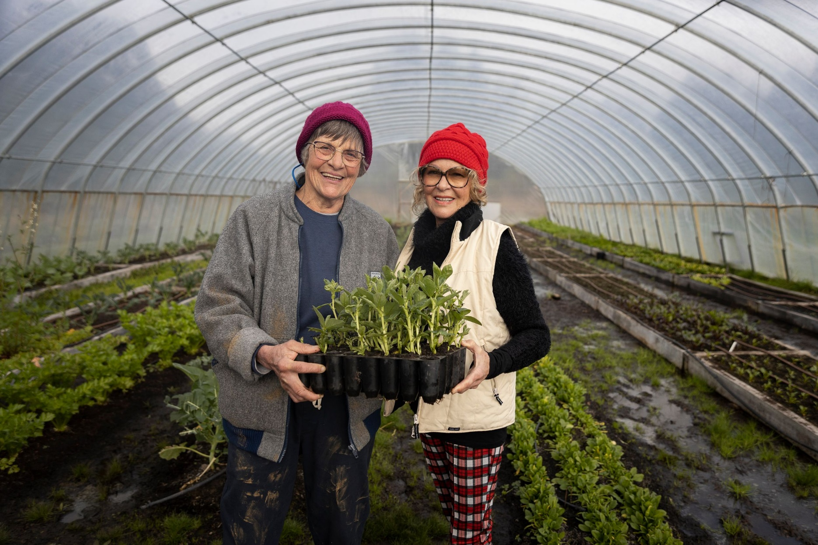

Huon Valley Council
Community Quick Response Grants

2021/2022 Guidelines and Application

The Huon Valley Council Community Grants Program provides financial assistance and in-kind support to projects that involve, engage, and benefit the Huon Valley Community. Applications will be assessed on an ongoing basis until funds have been exhausted.
These guidelines explain which organisations and projects are eligible to apply, how to complete an application and how the applications are assessed.
Huon Valley Council Officers can support community groups to develop the best application they can and encourage applicants to discuss their application with us before submitting.

Types of funding
Funding of up to $1,000 is available for activities that support community projects, creative projects and Town Team Projects that can be completed before 30 December 2022.
A total pool of $55,000 will be made available until funds are exhausted.
Funds will be split across 3 areas:
$25,000 for community projects – up to $1,000 to support a community project.
$10,000 for creative projects – up to $1,000 to support a creative project.
$20,000 for Town Teams projects – up to $1,000 to support a place-based activation project

Key dates
Applications Open September 2021
Projects completed By end December 2022
Acquittals to Council 1 month after completion of project

GRANT AIMS
Huon Valley Council grants build community capacity and resilience by supporting community-led projects. These grants aim to fund projects that support resources, programs, or services that:
- Promote community connection,
- Enhance the diversity of cultural, creative, health and well-being, recreational or social opportunities,
- Develop partnerships between charities, community groups or other organisations,
- Utilise local goods and services wherever possible, and.
- Enhance the Huon Valley as a prosperous, vibrant, and caring community.

Who Can Apply?
- Not for profit community-based groups whose project demonstrates a real benefit to the community.
- Individuals whose project demonstrates a real benefit to the community.

Who Can’t Apply?
- Australian or Local Government agencies or bodies.
- Tasmanian Government agencies except for schools.
- Government Business Enterprises.
- Political parties.
- Applicants who have not fulfilled the conditions of a previous Council grant.
- Groups that do not operate or provide services in the Huon Valley municipal area.

What can’t we fund?
- Ongoing administration or operational costs.
- Major capital works.
- Projects that make a significant profit or loss.
- Rate remissions.
- Projects that have already started.
- Late or incomplete applications.
- Projects taking place outside of the Huon Valley.
- Projects that do not clearly benefit the Huon Valley community.

How Do You Apply?
- Read these guidelines and check you are eligible.
- Talk with Council’s Community Liaison Officer and check funds are still available
- Complete the application form which can be found on the Huon Valley Council website www.huonvalley.tas.gov.au, or please email hvc@huonvalley.tas.gov.au or telephone (03) 6264 0300 to receive one via email or post
- Submit your application and support material (including quotes) by:
- Email: hvc@huonvalley.tas.gov.au or
- Post: Huon Valley Council, PO Box 210, Huonville TAS 7019
- In Person: Council’s Customer Service Centre, 40 Main Street, Huonville

How Are Applications Assessed?
Eligible applications will be assessed against the criteria listed below.
- How the project aligns with one or more of the aims listed above (30%),
- How the project builds capacity, strength, and creativity in our community (30%),
- How the project aligns with the Council’s Strategic Plan (20%), and
- How the project demonstrates that it is well planned, that suitably skilled people are involved, and that the applicant and the project are financially viable (20%).
Applications will be assessed on an ongoing basis and applicants will be notified of the outcome of their application as soon as possible. As soon as the funding pool has been expended the grant round will close. You must call Council’s Community Liaison Officer prior to submitting your application to confirm availability of funds.
Applications will be scored and assessed according to the criteria above, by an Assessment Panel of three or more relevant Council officers.
The Panel will make recommendations to the General Manager for final approval, through delegated authority.

Letter Of Offer
Successful applicants will be sent a formal Letter of Offer outlining the terms and conditions of the grant.
Grants will be paid:
- on provision of a signed Letter of Offer.
- on receipt of a tax invoice (inclusive of GST where applicable).
- on provision of an ABN or Statement by Supplier.

Acquittal
Upon completion of the project, successful applicants will be required to acquit their grant, providing details of the project, including expenditure, outcomes, and photos.
The Acquittal Report for Grants includes:
- Examples of the media coverage achieved including media clippings and images where available.
- Examples of how you acknowledged the support of Council.
- Local community support and participation achieved including evidence of community support.
- Any other data collected by organisers as part of the project evaluation process, including good quality, high resolution images.
Organisations that do not satisfactorily acquit their grant may not be eligible for future funding and may be required to return the funds allocated to their project.
Acquittal Reports can be found on the Council’s website: https://www.huonvalley.tas.gov.au/services/my-community/community-grants/

Recognition of Council Assistance
Successful applicants must acknowledge the Huon Valley Council’s support. A copy of the Council logo is available on request for inclusion in any media or publicity.
The following statement is to be included in all acknowledgements: “Supported by Huon Valley Council Grants Program”.

UNSUCCESSFUL APPLICATIONS
Unsuccessful applicants may discuss their application with the Director of Community Services. If your application is not successful, the decision does not necessarily reflect the worthiness or community benefit of the proposal. Feedback will be made available to all applicants.

Definitions
Community: The meaning of community within these guidelines is broken down into two areas: community as a distinct geographical area and community as a subjective and invisible entity defined by people’s sense of belonging and identity.
Not-for-profit: A not-for-profit organisation is one which is not operating for the profit or gain of its individual members, whether these gains would have been direct or indirect. A not-for-profit organisation can still make a profit/surplus, but this profit must be used to carry out its purposes and must not be distributed to owners, members, or other private people.
Ongoing administration or operational costs: These costs are not eligible for funding through this grants program. These costs include general expenses associated with the ongoing operation of your association or group and include things such as staff costs, advertising, and day-to-day administrative expenses, such as stationery. In the case of schools this also includes costs associated with the employment of teaching/support staff and/or the delivery of curricula.
In-kind support: ‘In-kind’ support is often accepted as an alternative, or additional, to a financial contribution. In-kind support includes the donations of goods or services that you may receive towards a project. Often, an organisation or group contributes to a project with their own resources, which may reduce the amount of actual dollars needed. But this doesn’t deny the fact that these contributions would had to have been paid for if these donations didn’t exist. Volunteering Tasmania has more information and a calculator that can be used to give a dollar value.
Venue Hire: If you are seeking to use Council venues as part of your proposed project, you must make a tentative booking before you submit your grant application. You will need to provide written evidence of this booking with your grant application, so that your application can be assessed. Please refer to the Council website for more information about venue bookings.
Capital works: Capital works are defined as building and engineering works that create an asset, as well as constructing or installing facilities and fixtures associated with, and forming an integral part of those works.
Community Project: A community based project builds on the identified strength and assets in the community, addresses identified needs in the community, benefits the local community and involves the local community.
Creative Project: A project that provides support to the arts and culture sector of the community. Art practices include but not restricted to visual arts, multi-media, music, performance, writing, digital, dance, festivals, and events. All creative endeavours should have creative, economic, social, cultural or community benefits and outcomes.
Town Teams Project: Projects that support place-based activation and /or beautification of a town. Whilst the project may partner with others, it must be led by a community group that aligns with the Town Team Charter and Guiding Principles.
Town-Team-Charter-Final.pdf (townteammovement.com)

Contact Officer
For further information regarding a project proposal for a Community Grant, please contact:
Michelle Churchill
Community Liaison Officer
Phone: (03) 6264 0300
Email: hvc@huonvalley.tas.gov.au

Cover image: Scrubby Hill Farm Open Day, coordinated by the Geeveston Community House and supported by a Huon Valley Council Quick Response Neighbourhood Get-together Grant 2021

HUON VALLEY COMMUNITY GRANT APPLICATION FORM
Contact Details
Applicant Name
Contact Name
Contact Address
Contact Phone
Contact Email
Project Details
Project Area  (Choose one) | Community Project  (Up to $1,000) |  |  | Creative Project  (Up to $1,000) |  | Town Team Project  (Up to $1,000)
Project Name
Brief Description
(25 words)
Community Need
(Describe what need in the community your project is addressing)
Huon Valley Council Strategic Plan
(Describe how your project aligns to one or more objectives)
Ongoing Benefits
(Describe how your event could help build ongoing connections between people)
Project SMART Goal (Describe what you are going to do and how)
Specific
(What do you hope to achieve in doing this project?)
Measurable
(How will you measure your success?)
Actions
(What steps will you take to complete the project?)
Realistic
(How will you achieve this with the resources available to you?)
Timeframe
(When will your project start and be completed by?)
Partnerships and Collaboration
(List the contributions (cash and in-kind) from other partners, volunteers, groups, etc)
Project Expenses (List the costs associated with your project)
Expense Name |  |  | Expense Description |  | Expense Cost
Support Material may include up to five images, quotes or documents relating to project expenditure (no page limit), letters of support.
Quotes MUST be attached.
Town Team Projects  (Please provide us with a bit more information if you are creating or changing an asset) |  | Provide proof that you have permission to undertake the project on land or with assets belonging to others (e.g. letter from landowner, Council etc)  Describe who will take ongoing responsibility for the new or improved asset.

How did you find out about this grants program?
☐ Council website
☐ Facebook
☐ Council e-Newsletter
☐ Instagram
☐ Huon News
☐ Huon FM
☐ Community Noticeboards
☐ Word of mouth
Other: __________________________________________________________________________________

